**Assignment : 1 Test API gateway using lambda function.**

**How?**

**#We will add a trigger with any lambda function and choose API gateway in trigger configuration.**

**Steps :**

**1** Create a lambda function : here we used a simple lambda function,

*import json*

*def lambda_handler(event, context):*

*# TODO implement*

*return {*

*'statusCode': 200,*

*'body': json.dumps('Hello from Lambda!')*

*}*

2 add trigger -> select API Gateway ->click Add

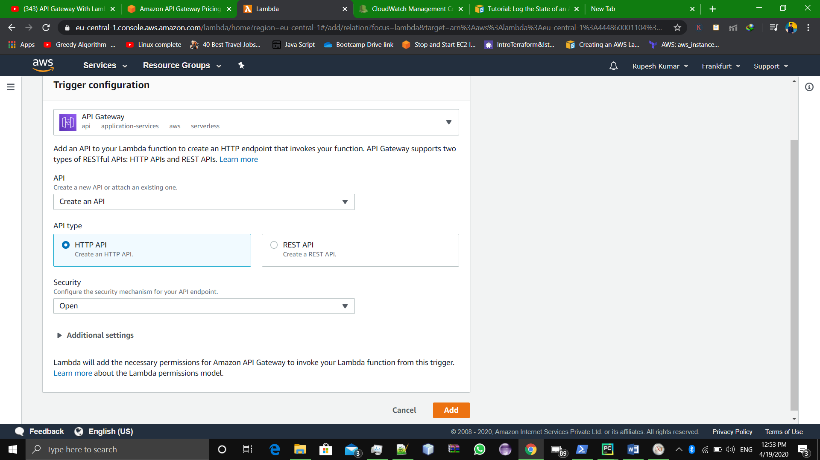

**Now our API Gateway has been created.**

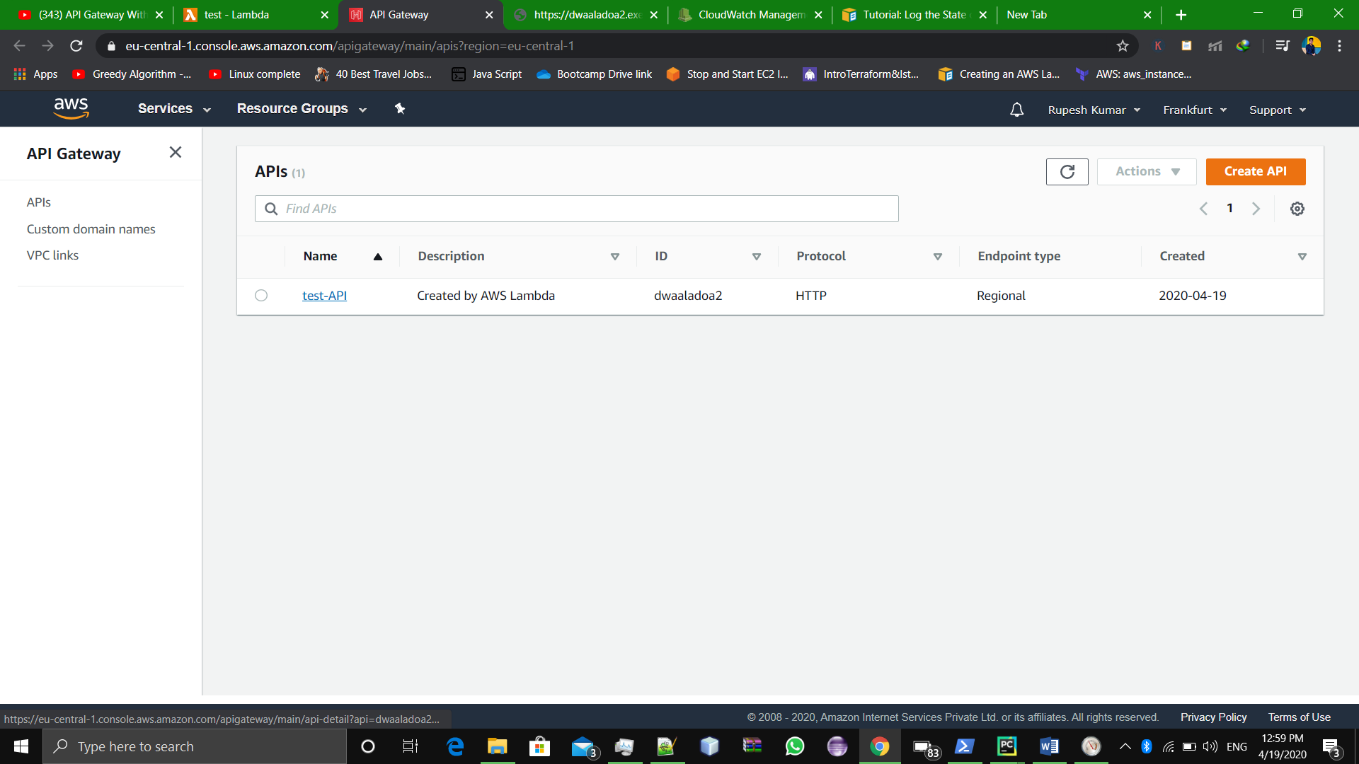

**And we can check whether it is running correctly by hitting the API Gateway URL;**

**That is** <https://dwaaladoa2.execute-api.eu-central-1.amazonaws.com/default/test> (in our case)

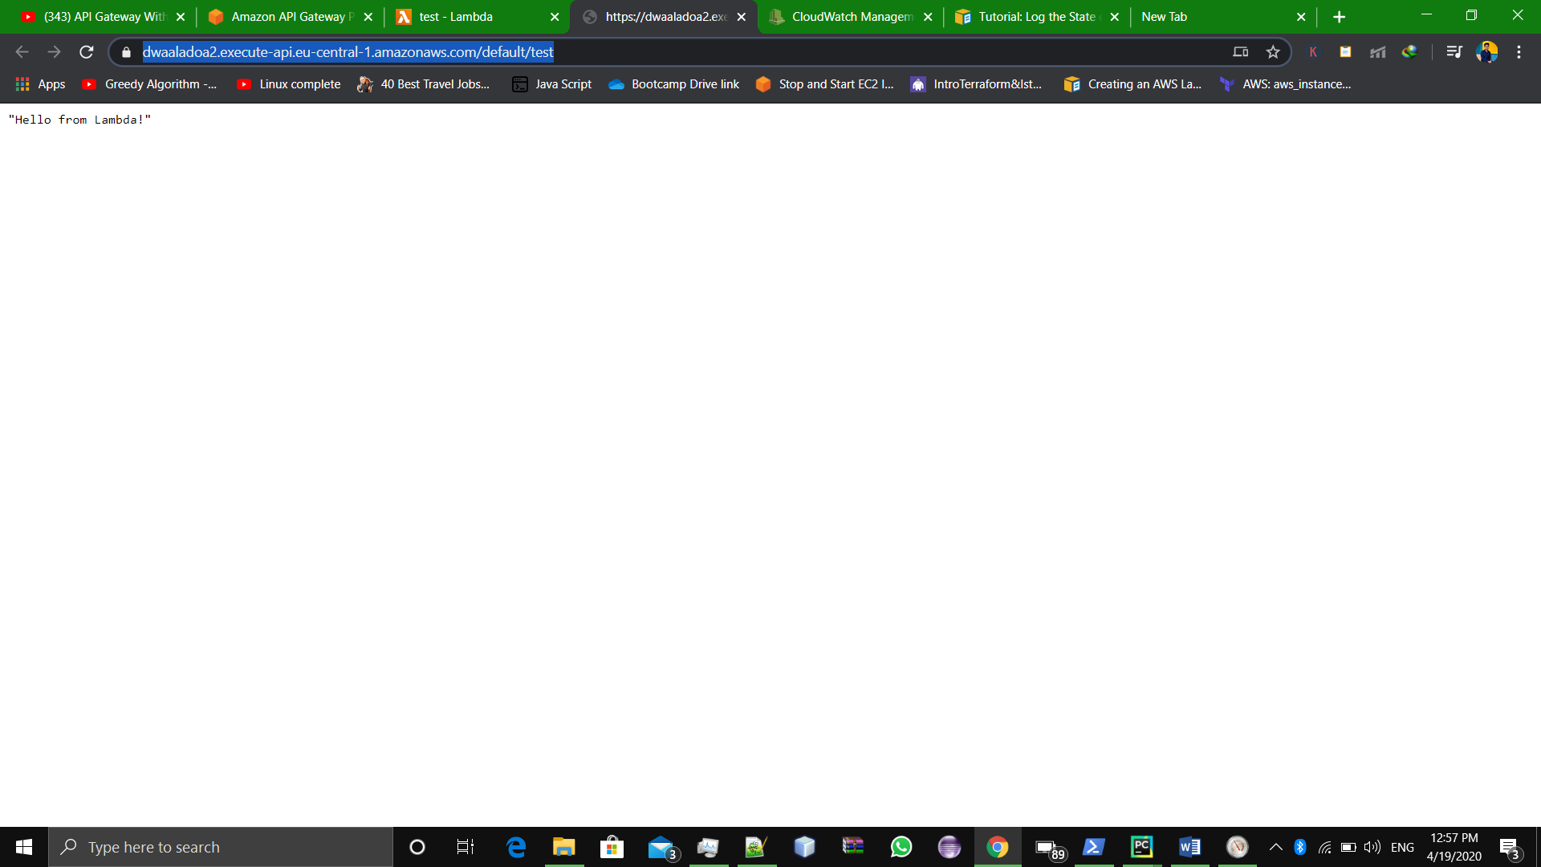

**#Completed.**

**Assignment : 2**

**(I)Staring state -> a pass type state with user input as : ‘start’, ’stop’ or ‘teminate’.**

**(II)Choice state -> 3 choices: Based on the given values, it will execute three lambda functions:**

**1 stopEc2**

**2 startEc2**

**3 terminateEc2**

**(III)Also add a fail state which will be executed, if you enter ‘exit. In your input json.**

**(IV)End State.**

**Solution:**

**Steps:**

First we should have three Lambda functions ready with us :

1 stopEc2

2 startEc2

3 terminateEc2

(these three lambda function we already created in Assignment no. 8)

Now move to create a **step function**

->create a new step function

->select **author with code snippet**

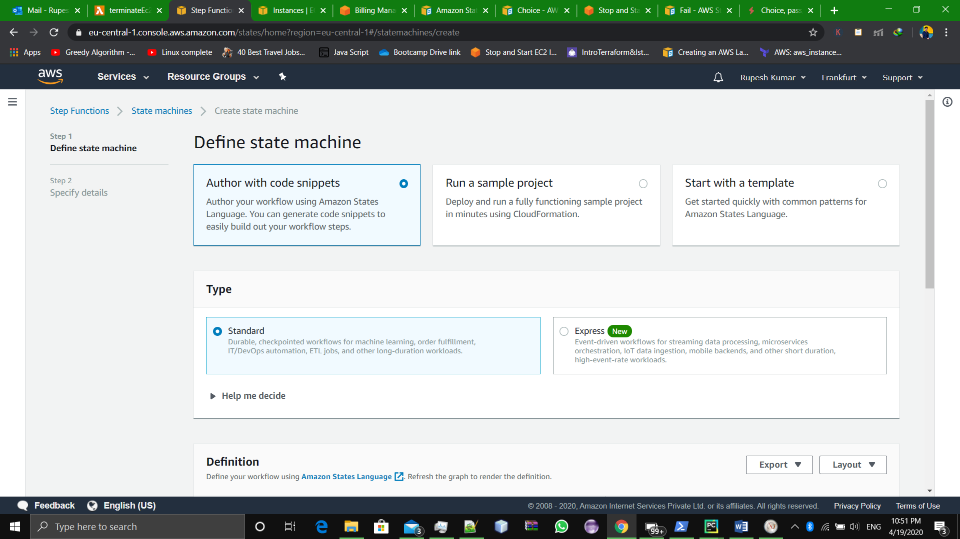

->edit the code and write this code mentioned below

*{*

*"Comment": "EC2 Instance State change events using Step function with Lambda",*

*"StartAt": "passing",*

*"States": {*

*"passing":{*

*"Type":"Pass",*

*"Next":"Checking"*

*},*

*"Checking": {*

*"Type": "Choice",*

*"Choices" : [*

*{*

*"Variable":"$.st",*

*"StringEquals": "stop",*

*"Next" : "stopEc2"*

*},*

*{*

*"Variable":"$.st",*

*"StringEquals": "start",*

*"Next" : "startEc2"*

*},*

*{*

*"Variable":"$.st",*

*"StringEquals": "terminate",*

*"Next" : "terminateEc2"*

*},*

*{*

*"Variable":"$.st",*

*"StringEquals":"exit",*

*"Next":"failSt"*

*} ]*

*},*

*"startEc2":{*

*"Type":"Task",*

*"Resource":"arn:aws:lambda:eu-central-1:444860001104:function:startEc2",*

*"End":true*

*},*

*"stopEc2":{*

*"Type":"Task",*

*"Resource":"arn:aws:lambda:eu-central-1:444860001104:function:stopEc2",*

*"End":true*

*},*

*"terminateEc2":{*

*"Type":"Task",*

*"Resource":"arn:aws:lambda:eu-central-1:444860001104:function:terminateEc2",*

*"End":true*

*},*

*"failSt": {*

*"Type": "Fail",*

*"Cause": "User Entered exit"*

*} } }*

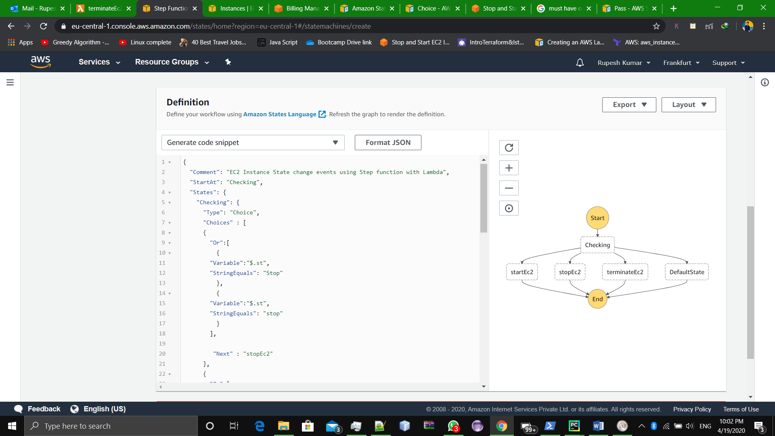

This is our flow diagram!

* Hit **NEXT** button
* Give a suitable Name and define IAM role
* Enable logs
* Hit **create state machine**

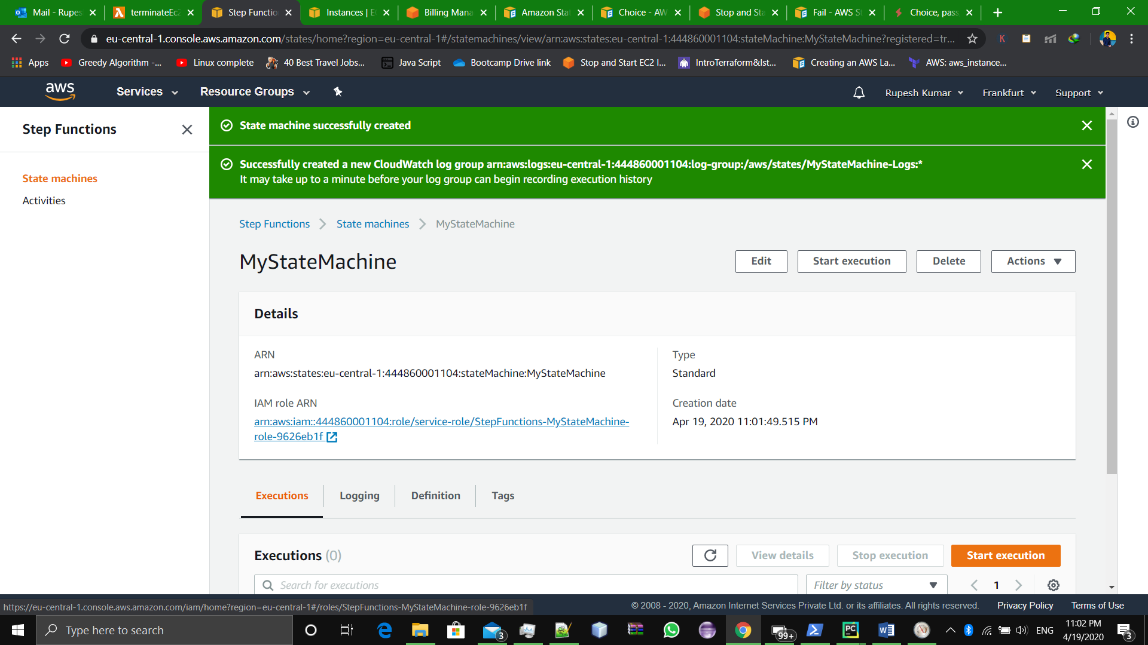

Successfully created.

Now test this.

* Give input values
* We have given:

{

#our variable name is st

“st” : start

}

* It executed successfully.

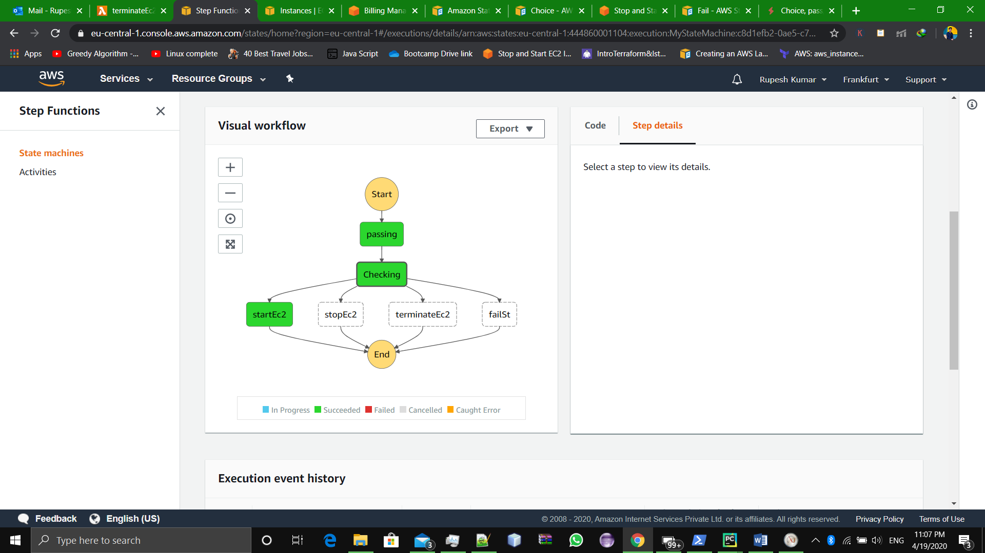

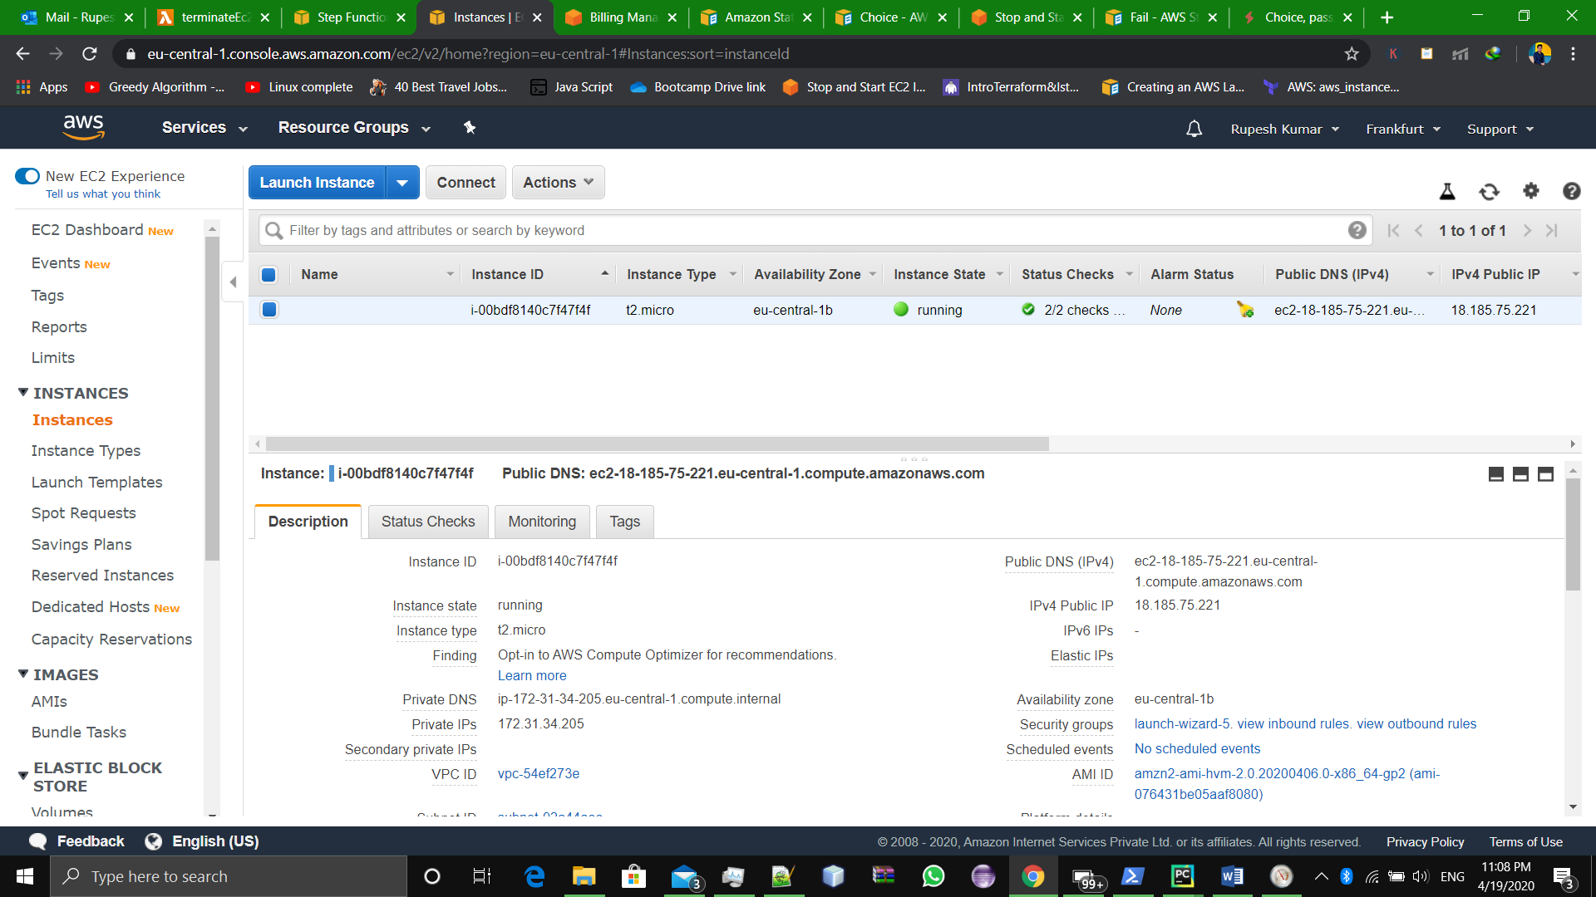

Ec2 instance screenshot

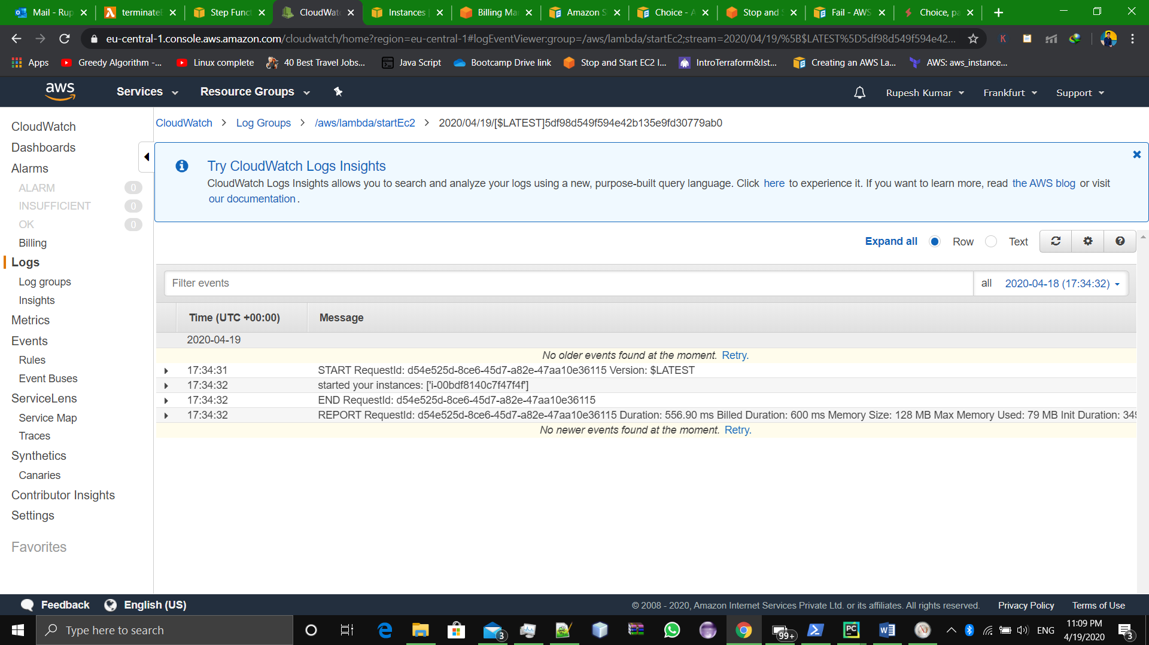

cloudWatch Logs

#Lets try one more time with input as ‘exit

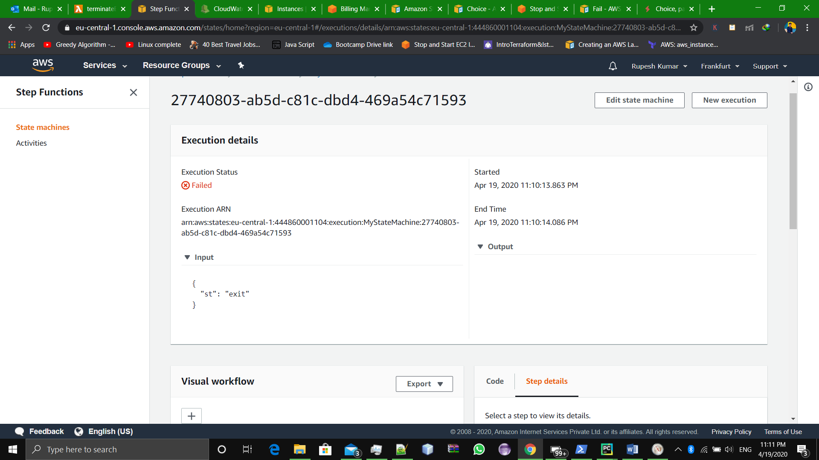

It failed as expected.

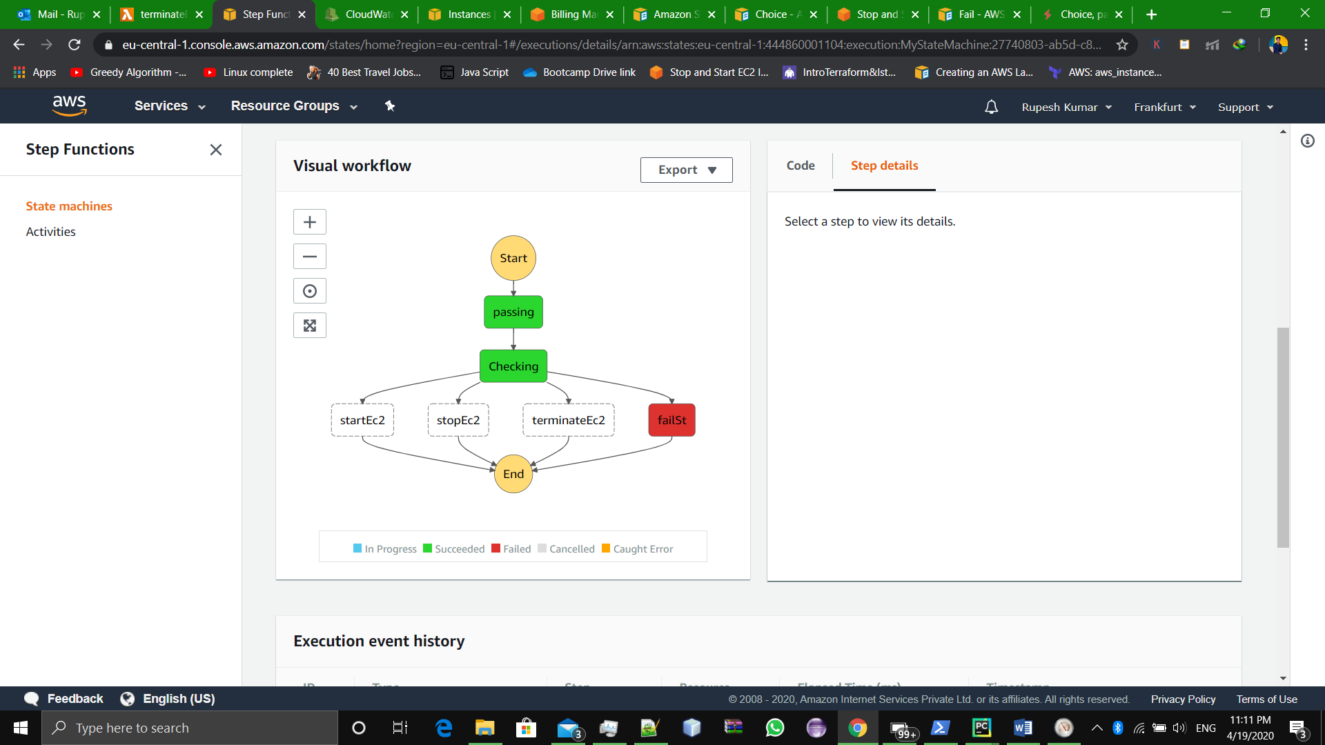

**#Completed.**